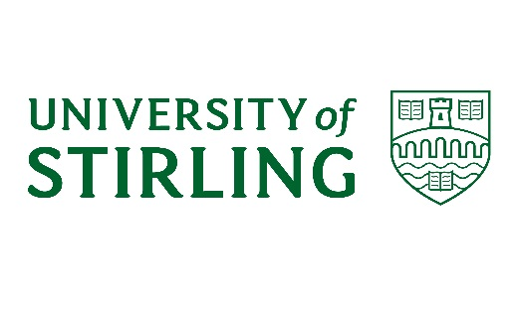
Consent form for filming/photography - by email
Copy below the line is to be used for requesting students to give consent to the University of Stirling to use their images or videos.
The photo and/or video still and emailed consent from the student must be printed and passed to CMR office admin for data storage.
------------------------------------------------------------------------------------------------------
Please reply to this email to confirm that you give consent to below.
Please could you also confirm the following details:
Full name:

Nationality:

Course name:

Year:

I consent to the University of Stirling and/or its official global education partners using:
- photographs of me
- video recordings including images of me
- audio recordings of me
- contributory quotes from me
- personal information which could include my name, origin and course studied
- photographs or video contributed by me for use by the University
Images and personal information could be used in print and digital media formats including print publications, websites, e-marketing, posters, banners, advertising, film, social media, teaching and research purposes.
I understand that images and content on websites can be viewed throughout the world and not just in the United Kingdom and that some overseas countries may not provide the same level of protection to the rights of individuals as EU/UK legislation provides.
I understand that some images or recordings may be kept permanently once they are published and be kept as an archive of University life.
I understand that the quotation responses may be edited for use within our marketing materials and online, but the context of my response will remain unchanged.
I have read and understand the conditions and consent to my images, quotes (including my names, origin and course studied) being used as described.

I understand that the University of Stirling will not sell or share this content or information with third parties (except official global education partners). The personal data collected on this form will be held securely and will only be used for administrative purposes.

Your rights
You have the right to request to see a copy of the information we hold about you and to request corrections 0or deletions of the information that is no longer required. You can ask the University to stop using your images or testimonial at any time, in which case it will not be used in future publications but may continue to appear in publications already in circulation.

You have the right to lodge a complaint against the University regarding data protection issues with the Information Commissioner’s Office (https://ico.org.uk/concerns/).

Contact details
If you have any questions relating to this consent form or the way we are planning to use your information please contact:
Communications, Marketing & Recruitment
University of Stirling
Stirling
FK9 4LA
communications@stir.ac.uk

If you have any questions relating to data protection please contact the University’s Data Protection Officer, Joanna Morrow, tel: 01786 467030, email data.protection@stir.ac.uk

